PYTHON FOR DATA ANALYTICS
MODULE 1 • POINT 2
Introduction to VS Code
Learning Goal
Understand what Visual Studio Code is, how to create a Python file, write a simple program, run it and view the output.

1. What is VS Code?
Visual Studio Code (VS Code) is a lightweight code editor used to write, edit and run programs. It provides useful features such as syntax highlighting, extensions, debugging and an integrated terminal.
For this course, VS Code will be our main workspace for writing Python programs.

2. Why Use VS Code for Python?
- Simple and beginner-friendly interface
- Supports Python through an extension
- Integrated terminal for running commands
- Syntax highlighting makes code easier to read
- Useful error checking and debugging features

3. Basic VS Code Workflow
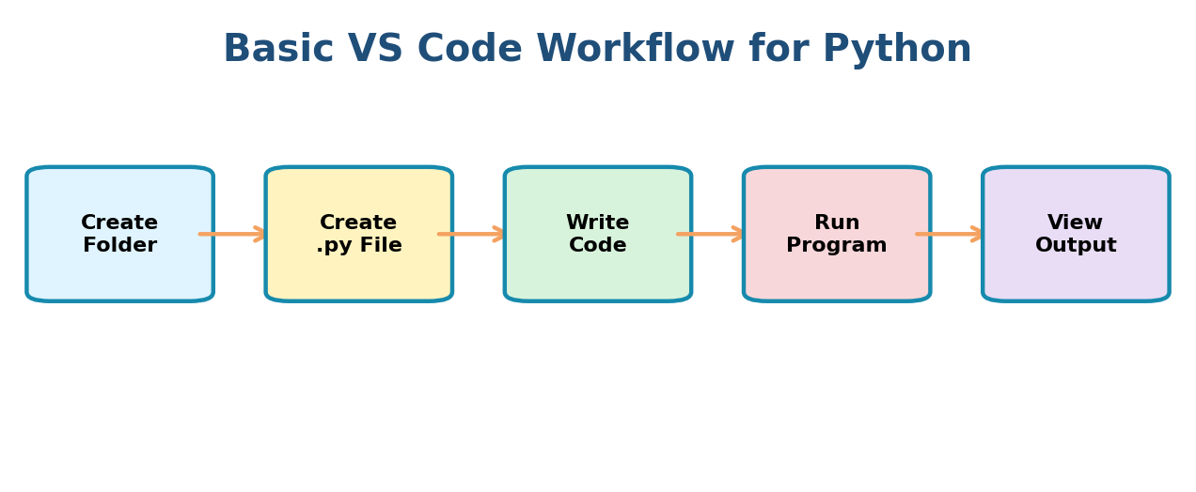
The basic process is: create a project folder → create a Python file → write code → run the program → check the output.

4. Create Your First Python File
- Open VS Code.
- Open or create a folder for your Python course.
- Create a new file named hello.py.
- Write your Python code.
- Save the file before running it.
print("Hello, Python!")
Important
Python files normally use the .py extension. For example: hello.py, variables.py and sales_analysis.py.

5. Running Python Code
You can run a Python file using the Run button in VS Code or from the integrated terminal.
python hello.py
The output will appear in the Terminal panel:
Hello, Python!

6. VS Code Interface — Important Areas
Area | Purpose
Explorer | View folders and files in the project
Editor | Write and edit Python code
Terminal | Run Python commands and programs
Extensions | Install tools such as the Python extension
Run / Debug | Run the program and troubleshoot code

7. A Simple Data Analytics Example
Once Python is working in VS Code, we can begin writing simple analytics programs.
sales = [12000, 15000, 18000]
total_sales = sum(sales)
print(f"Total Sales: ₹{total_sales:,}")
Output:
Total Sales: ₹45000

8. Common Beginner Mistakes
- Saving the file without the .py extension
- Running the command from the wrong folder
- Python is not installed or is not available in the terminal
- Not installing/enabling the Python extension
- Writing code but forgetting to save the file

9. Best Practices
- Create one organized folder for each course or project
- Use meaningful file names such as variables.py or sales_analysis.py
- Save your code frequently
- Run small programs often while learning
- Read terminal error messages carefully instead of ignoring them

10. Key Takeaways
- VS Code is the code editor we will use for the course.
- Python programs are saved in .py files.
- The Editor is where we write code and the Terminal shows program output.
- The Python extension adds useful Python development features.
- Students should practice creating, running and modifying small programs.
POINT 2 COMPLETE

